Credit Card Fraud Detection (Netica)
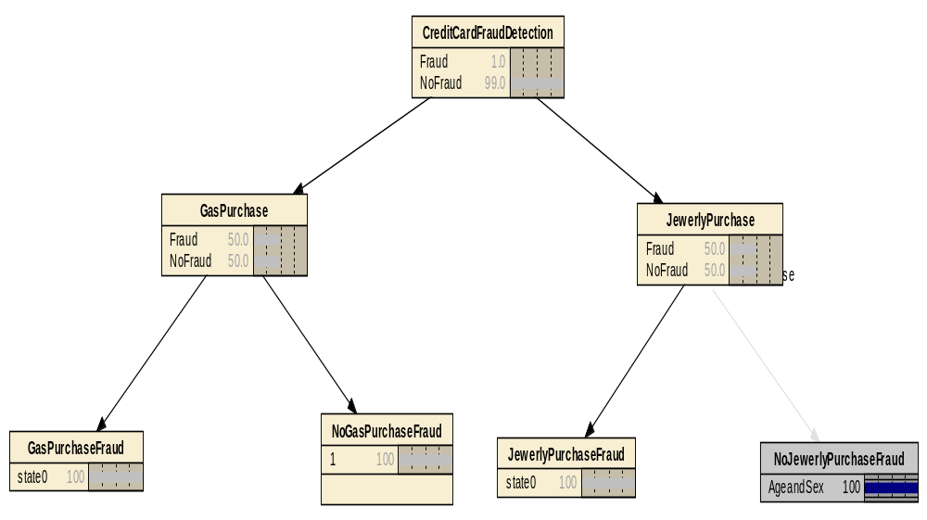

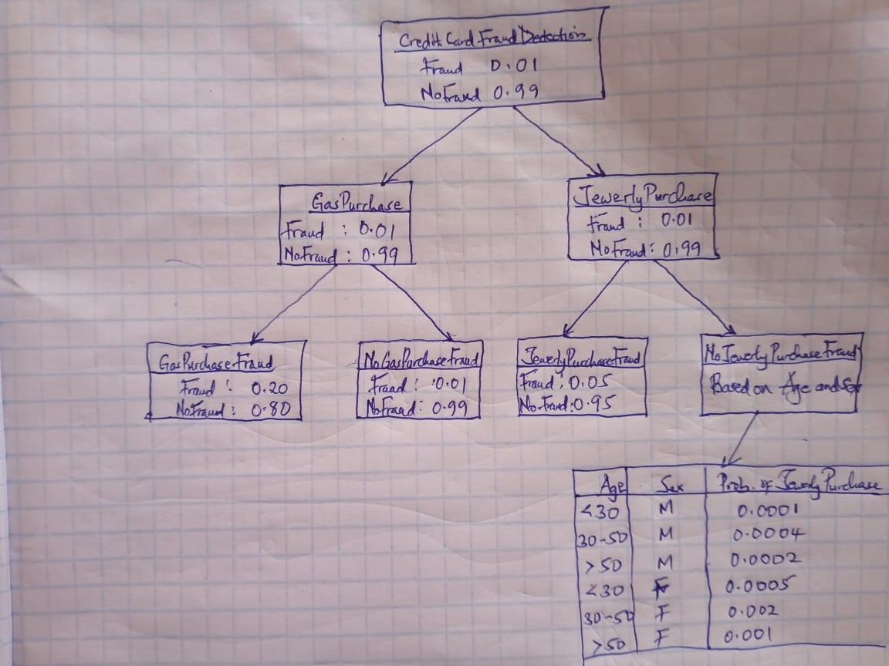

B. List the variable values maximize and minimize the probability of a fraud and list those probability.
Variables | P(Maximized fraud) | P(Minimized fraud)
- Credit Card Fraud | 0.01 | 0.0001
- No Credit Card Fraud | 0.99 | 0.009
- Gas Purchase | 0.01 | 0.001
- No Gas Purchase Fraud | 0.99 | 0.009
- Gas Purchase Fraud | 0.20 | 0.19
- Jewelry Purchase | 0.80 | 0.79
- Jewelry Purchase Fraud | 0.05 | 0.049
- No Jewelry Purchase Fraud | 0.95 | 0.049

C. Bayes Net:
P(Fraud/gasPurchase,jewerlyPurchase) = 0.99
P(Fraud/gasPurchase,-(No)jewerlyPurchase) = 0.80
P(Fraud/-(No)gasPurchase,jewerlyPurchase) = 0.002
P(Fraud/-(No)gasPurchase,-(No)jewerlyPurchase) = 0.005

